**Use Case Diagram:**

s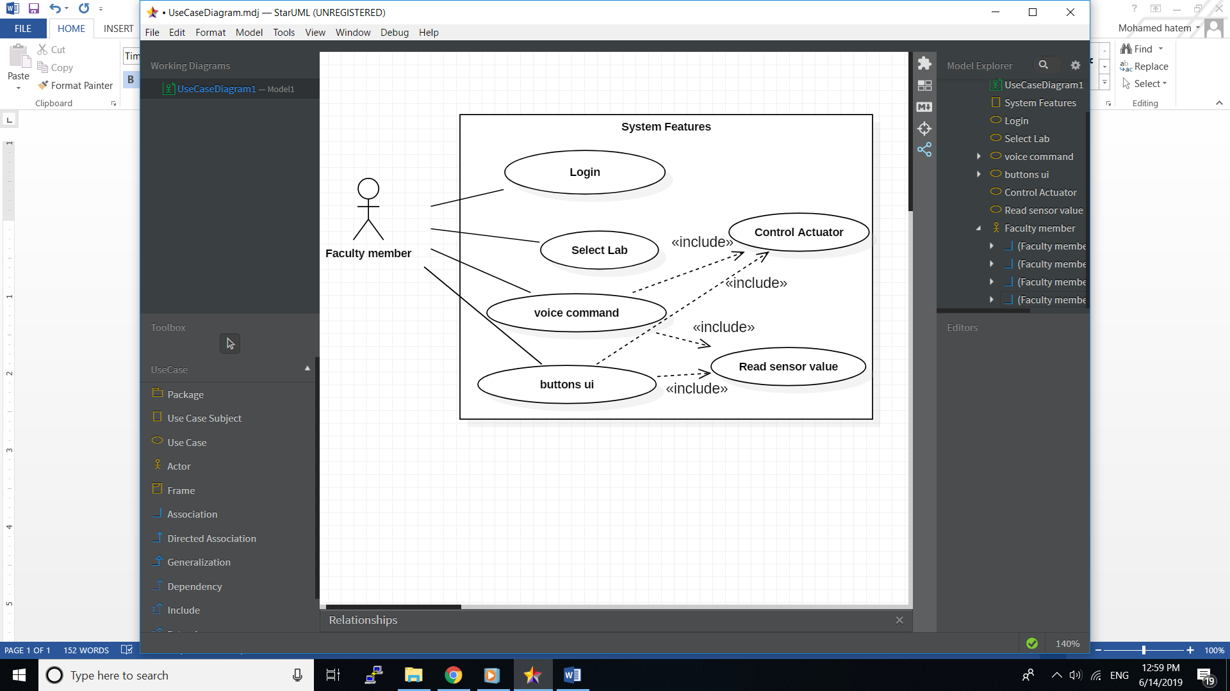

**Functional Requirements:**

* Authentication using Account (username, password).
* User shall interact with the smart lab via voice command or buttons.
* User should be able to retrieve readings from the sensors.
* User is able to see all the devices that can be controlled remotely.
* Results of a command will be shown to the user.
* User should be able to turn devices in the smart lab on and off.

**Non-Functional Requirements:**

**-Security:** password is encrypted using sha256.

**-Usability:** mobile application UI has well defined and well understood design for easy usage by users.

**-Performance:** response from the platform should not exceed 5 seconds.

**-Efficiency:** in case of no network connection, there won’t be an attempt to send any data, which reduces data usage in the system.

**-Extensibility:** much work has been put in the design of the system to allow for easy integration with new features.